# Estimating the actual soil moisture regime of relative soil moisture ranks in biogeoclimatic units from modeled climate data and vegetation indicators.

William H MacKenzie

4 September 2018

Abbreviations: aSMR: actual soil moisture regime; BEC: Biogeoclimatic Ecosystem Classification; BGC: Biogeoclimatic; **rSMR**: relative soil moisture regime;

In Biogeoclimatic Ecosystem Classification (**BEC**), the estimation of relative soil moisture regime (**rSMR**) is one of the essential environmental assessments in the collection of ecosystem plot data for the development of the classification. Typically using one of the standard rSMR keys available in the Field Manual for Describing Terrestrial Ecosystems (Province of BC 2015) See Appendix I

**rSMR** ranks terrestrial sites from the driest on the landscape (**rSMR** = 0 [very xeric]) to the wettest (**rSMR** = 7 [subhydric])[1] based on site and soils properties. These rankings are independent of the climate regime that determine the actual soil moisture (**aSMR**) of sites. Assessment of **rSMR** is also made independently of vegetation indicators in the construction of the classification, though once the relationships between vegetation communities and site conditions are known for a **BGC** and presented in the classification, vegetation becomes a reliable and rapid attribute for assessment of site moisture regime.

The relative position Site Series in the environment within a subzone/variant are typically displayed on an edatopic grid of relative soil moisture and soil nutrients regimes (Figure 1).

To allow inter-**BGC** unit comparisons based on moisture regimes and to allow modelling of climate change effects on site moisture, understanding the actual soil moisture regime of relative soil moisture position within a **BGC** climate is required.

The relationship between a **BGC**s **rSMR** and the actual soil moisture regime were created by regional ecologists in the early 1990s based on observed vegetation communities occurring in **rSMR** positions. The expert **aSMR** x **rSMR** grid covers did not include all historic **BGC**s nor those developed subsequently (131 of the current 211 **BGC** units). In addition, since the expert matrix was build by each region individually and is also based on personal assumptions of SMR indicator values of vegetation is may be expected that there is inconsistency in calls between regions.

The model presented here builds the relationship between **rSMR** within **BGC** subzone/variants to the actual Soil Moisture Regime (**aSMR**) scale of Klinka () from the climatic moisture deficit (CMD) and dormant season precipitation variables available in the ClimateBC surface. The initial goal is to build a **rSMR** x **aSMR** model that matches the historic expert grid as closely as possible.

Creation of this model is intended to meet several objectives:

1. Assist in the completion of a full matrix of **rSMR** x **aSMR** relationships by approximating aSMR or rSMR from climate data in **BGC**s that lacking previous assessments.
2. Assess and improve the consistency of **rSMR** x **aSMR** assessment between regions.
3. Make an explicit linkage between climate and **rSMR** to **aSMR** for use in climate change modelling.
4. Build a quantitative method of assessing aSMR of sites using vegetation indicators of aSMR for assessment the expert or modelled grids and for assessment of individual site series or plots with no or possibly incorrect rSMR assignments.

Methods:

Input is 100 random points per **BGC** from the most current **BGC** spatial coverage (2018 = **BGCv11**)

1961-1990 normal period climate data is extracted from ClimateBC (2018 = v5.60)

CMD is based on the Hargreaves evapotranspiration potential adjusted by precipitation (see Appendix I), The climate surface CMD directly relates to **rSMR** = 4 within a climate regime as the soils and site conditions are believed to best reflect regional climate.

Approach:

1. Seek to minimize sum of deviations from the expert grid.
2. Plot the range of CMDs by expert aSMR of rSMR sites to determine initial CMD ranges of aSMR classes for rSMR = 4
3. Adjust ranges to minimize the sum of aSMR category deviations between the model and the expert assessments.
4. Step-wise change CMD increase by step of drier rSMR to minimize sum of differences
5. Test the aSMR assignment of zonal ecosystems by vegetation analysis.

Ranges of CMD values that equate to a specific aSMR classes were determined from examination of the data (Figure ##) and then stepwise adjusted to minimize the sum of deviations between expert and modelled aSMRs.

Two further adjustments where made in baseline CMD:

* Increase CMD where low dormant season precipitation is insufficient to recharge the water table. CMD deficit = (300 – (PPT_at + PPT_wt)) where positive.
* Decrease CMD where heavy snowpack persists into the growing season by removing monthly CMDs up to and including June. This includes the ICHvc, ICHvk, SBSvk, BWBSvk.

Equal sized range widths spanning 150 CMD were determined to be the best fit to the data.

Table 1. CMD values that equate to aSMR categories.

|  |  |  |  |  |
| --- | --- | --- | --- | --- |
| **aSMR** | **rSMR 0-4** | **rSMR5** | **rSMR6** | **rSMR7** |
| **XD** | 675-825+ |  |  |  |
| **ED** | 525-675 |  |  |  |
| **VD** | 375-525 |  |  |  |
| **MD** | 225-375 | 175-225+ |  |  |
| **SD** | 75-225 | 125-175 |  |  |
| **F** | 5-75 | 75-125 | 75-125+ |  |
| **M** | 0-5 | 0-75 | 25-75 |  |
| **VM** |  |  | 0-25 | 25-50+ |
| **W/VM** |  |  | 0 | 0-25 |

#### CMD in drier rSMR ranks

CMD was increased by an equivalent amount for each rSMR rank drier than zonal. Again, a heuristic approach was taken to find a CMD step value that created the closest match to the expert values as possible by minimizing the sum of deviations between the model and the expert assessments.

100 CMD is added for each drier **rSMR** rank

#### CMD in wetter rSMR ranks

For wetter rSMR categories, CMD was divided by two at each subsequently wetter rSMR.

CMD is divided by 2 for each wetter **rSMR** rank

1. Seek to minimize sum of deviations from the expert grid.
2. Plot the range of CMDs by expert aSMR of rSMR sites
3. Step wise change CMD increase by step of drier rSMR to minimize sum of differences
4. Test the aSMR assignment of zonal ecosystems by vegetation analysis.

Discussion:

Discrepancy between expert and modelled from:

* Climate Surface model errors (discrepancies in many rSMRs)
* Poor model, incomplete variables selection, improper variable ranges
* Expert mis-assignment (Vegetation analysis)

Test of assignment to be made using species indicator values of plots assigned to plots with edatopic position and/or by summary vegetation values of site series.

* Edatopic position of site series converted to **aSMR**
* Know SMR indicator values of species
* Generate SMR indicator values of species by analysis. (relative position in ordination space)

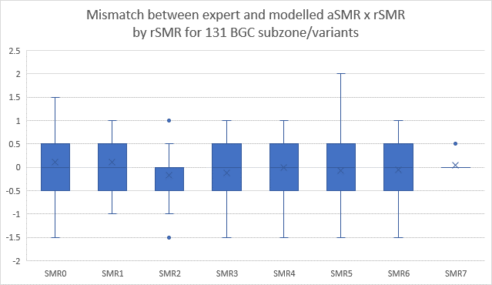

Positive

**Hargreaves equation**: This method uses solar radiation above the atmosphere, the monthly mean temperature and the mean daily temperature range for the latitude of the site and the day of the year in the middle of the month (Hargeaves and Samani 1982, Shuttleworth 1993):

EHar = 0.0023 d S0 (Tm + 17.8) Tr0.5 Tm≥0

EHar=0 Tm<0

S0 = 15.392 ζ ([ωs sin φ sin δ] + [cos φ cos δ sin ωs ])

ξ = 1 + 0.033 cos(0.0172 J)

ωs = arccos(-tan φ tan δ) [6]

δ = 0.4093 sin(0.0172 [J - 81])

Tm = (Tmaxm + Tminm)/2

Tr = Tmaxm - Tminm

where d is the number of days in the month, S0 is the water equivalent of the radiation above the atmosphere (mm d-1) at the latitude of the site (φ radians) for day of the year (J) in the middle of the month, Tm is the monthly mean daily temperature (°C), Tmaxm and Tminm are the monthly maximum and minimum air temperatures (°C), δ solar declination in radians, and ξ is the relative distance of the earth from the sun on J. The mean daily temperature range (Tr) is the difference between the monthly mean maximum and minimum temperatures. (Note that Shuttleworth (1993) has omitted the square root on Tr in his presentation)

Based on a comparison with reference evaporation from the Penman-Monteith equation (Allen et al. 1998) for sites in western North America, the monthly evaporation (Em) is calculated by adjusting the Hargreaves evaporation using the site latitude,

Em = EHar (1.18 - 0.0065 Latitude)

Em is summed to give the annual total. The daily temperature range can be considered an empirical adjustment for the effect of the cloudiness of the atmosphere on the solar radiation reaching the surface. It also is related to the vapour pressure deficit.

TABLE 1. Classification of actual soil moisture regimes (Klinka et al. 2000)

|  |  |  |  |
| --- | --- | --- | --- |
| **Soil water balance** | **Actual Soil Moisture Regime** | **aSMR code** | **aSMR number** |
| Deficit > 7 months (AET/PET ≤ 30%) | Extremely Dry | ED | 0 |
| Deficit > 5 months but <= 7 months (AET/PET ≤ 55% but > 30%) | Excessively Dry | XD | 1 |
| Deficit > 3 months but ≤ 5 months (AET/PET ≤ 75 but > 55%) | Very Dry | VD | 2 |
| Deficit > 1.5 months but ≤ 3 months (AET/PET ≤ 90 but > 75%) | Moderately Dry | MD | 3 |
| Deficit > 0 but ≤ 1.5 months (AET/PET > 90%) | Slightly Dry | SD | 4 |
| Deficit = 0. But utilization of soil-stored water occurs | Fresh | F | 5 |
| Soil water inputs exceeds requirements and no utilization occurs. A temporary groundwater table may be present. | Moist | M | 6 |
| Rooting-zone groundwater present during the growing season |  |  |  |
| Groundwater table > 60 cm deep | Moist | M | 6 |
| Groundwater table > 30 cm deep | Very Moist | VM | 7 |
| Groundwater table > 0 but ≤ 30 cm deep | Wet | W | 8 |
| Groundwater table at or above the ground surface very wet | Very Wet | VW | 9 |

Insert characteristics of **rSMR** keys, etc

References:

Climate

Allen, R.G., L.S. Pereira, D. Raes, and M. Smith. 1998. Crop evapotranspiration – guidelines for computing crop water requirements. FAO Irrigation and Drainage Paper FAO56, U.N. Food and Agriculture Organization, Rome. www.fao.org/docrep/x0490E

Hargreaves, G.H. and R.G. Allen. 2003. History and Evaluation of Hargreaves Evapotranspiration Equation. Journal of Irrigation and Drainage Engineering, 129, 53-63. 

Hargreaves, G.A., and Z.A. Samni.1982. Estimating potential evapotranspiration. J. Irrigation and Drainage Div., Proc Am Soc. Civil Engineers. 108:223-230.

Maurer, G. E., and D. R. Bowling (2014), Seasonal snowpack characteristics influence soil temperature and water content at multiple scales in interior western U.S. mountain ecosystems, Water Resour. Res., 50, 5216–5234, doi: 10.1002/2013WR014452.

Shuttleworth, W. J. 1993. Evaporation. In Handbook of Hydrology, D.R. Maidment (ed), McGraw-Hill Inc., New York, pp. 4.1-4.53.

Vegetation Indicator Values

Klinka, K., V.J. Krajina, A. Ceska, A.M. Scagel. 1989. Indicator Plants of Coastal British Columbia. UBC Press. Vancouver, BC. 288pp.

Klinka, K., J. Worrall, L. Skoda, P. Varga. 2000. The Distribution and Synopsis of Ecological and Silvical Characteristics of Tree Species of British Columbia’s Forests. Canadian Cartographics, Vancouver, British Columbia. 180pp.

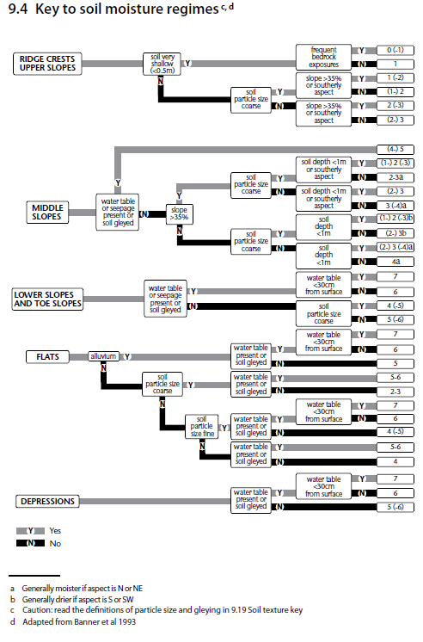

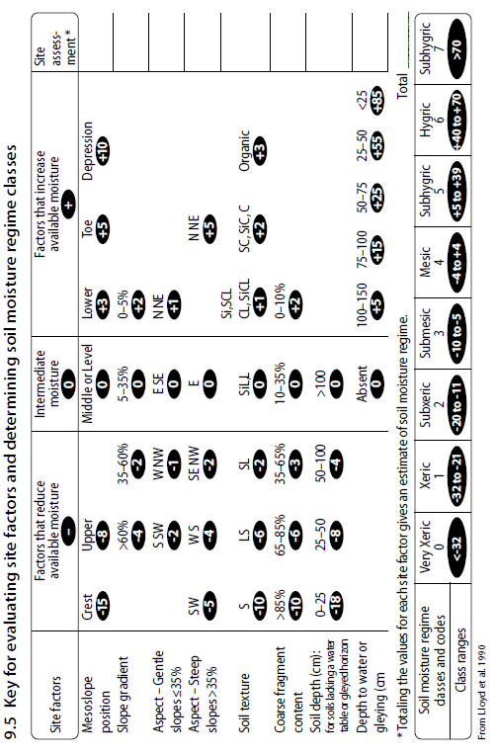

A close up of text on a white background

Description generated with high confidence

1. Hydric sites (rSMR=8) are defined but represent aquatic sites where the water table is above the soil surface.